Argentina

29% Union Ciudadano

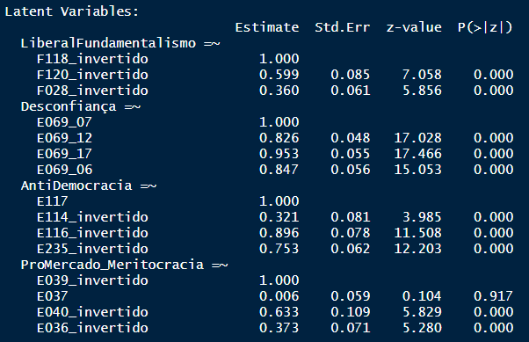

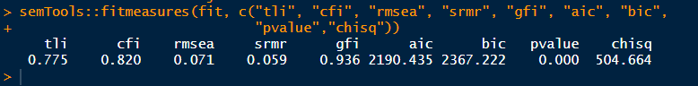

|  |  |  |  |  |
| --- | --- | --- | --- | --- |
| Unidad_Ciudadano | Unidad_Ciudadano | Unidad_Ciudadano | Unidad_Ciudadano |  |
| Predictors | Odds Ratios | Odds Ratios | Odds Ratios | Odds Ratios |
| (Intercept) | 0.57  (0.39) | 0.42 *** (0.03) | 0.90  (0.18) | 0.88  (0.67) |
| X049 | 1.11 * (0.06) |  |  | 1.09  (0.06) |
| Gender | 1.03  (0.17) |  |  | 1.12  (0.19) |
| rend_subjLow | 1.62  (0.60) |  |  | 1.76  (0.72) |
| rend_subjMedium | 0.94  (0.31) |  |  | 1.08  (0.40) |
| rend_subjHigh | 0.68  (0.32) |  |  | 0.87  (0.43) |
| region32002 | 1.50 * (0.30) |  |  | 1.56 * (0.34) |
| region32003 | 0.00  (0.00) |  |  | 0.00  (0.00) |
| region32004 | 1.20  (0.64) |  |  | 1.51  (0.85) |
| region32005 | 1.40  (0.73) |  |  | 2.21  (1.22) |
| region32006 | 0.05 ** (0.05) |  |  | 0.06 ** (0.06) |
| region32007 | 1.63  (0.85) |  |  | 1.57  (0.88) |
| region32012 | 0.17  (0.18) |  |  | 0.18  (0.20) |
| region32013 | 1.37  (0.55) |  |  | 1.16  (0.51) |
| region32017 | 0.94  (0.52) |  |  | 1.02  (0.61) |
| region32019 | 2.26  (1.17) |  |  | 2.18  (1.21) |
| region32021 | 0.66  (0.23) |  |  | 0.77  (0.28) |
| region32024 | 1.36  (0.95) |  |  | 1.62  (1.19) |
| ethnic_groupLight Brown | 0.95  (0.18) |  |  | 0.91  (0.18) |
| ethnic_groupOther Brown | 0.81  (0.25) |  |  | 0.83  (0.27) |
| idade_faixa | 0.79 * (0.09) |  |  | 0.83  (0.11) |
| escolaridade_niveis | 0.66 *** (0.08) |  |  | 0.62 *** (0.08) |
| status_emploSelf Employed | 1.04  (0.21) |  |  | 1.02  (0.22) |
| status_emploHousewife | 1.44  (0.43) |  |  | 1.61  (0.50) |
| status_emploRetired | 1.00  (0.26) |  |  | 1.09  (0.30) |
| status_emploStudent | 0.56  (0.18) |  |  | 0.64  (0.22) |
| status_emploOthers | 1.13  (0.31) |  |  | 1.32  (0.39) |
| religionDo not belong to a denomination | 1.11  (0.22) |  |  | 0.88  (0.19) |
| religionOthers | 1.23  (0.28) |  |  | 1.35  (0.34) |
| fundamentalism |  | 1.12  (0.37) | 1.42  (0.49) | 0.96  (0.37) |
| antidemocr |  | 0.22 * (0.15) | 0.39  (0.28) | 0.55  (0.46) |
| desconfia |  | 1.40  (0.64) | 2.12  (1.05) | 2.12  (1.15) |
| promercado |  | 0.16 *** (0.08) | 0.19 ** (0.10) | 0.31 * (0.17) |
| autoloc_dir_esqCenter |  |  | 0.42 *** (0.09) | 0.43 *** (0.10) |
| autoloc_dir_esqRight |  |  | 0.22 *** (0.04) | 0.26 *** (0.06) |
| autoloc_dir_esqDon't Know |  |  | 0.34 *** (0.08) | 0.28 *** (0.08) |
| interesse |  |  | 1.64 * (0.40) | 2.00 ** (0.53) |
| Observations | 1003 | 1003 | 997 | 997 |
| R2 Tjur | 0.112 | 0.019 | 0.091 | 0.182 |
| * p<0.05   ** p<0.01   *** p<0.001 | | | | |

#

Bolívia

32% MAS

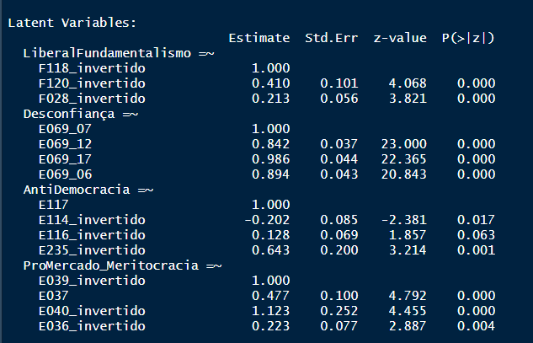

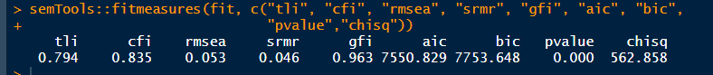

|  |  |  |  |  |
| --- | --- | --- | --- | --- |
| MAS_ | MAS_ | MAS_ | MAS_ |  |
| Predictors | Odds Ratios | Odds Ratios | Odds Ratios | Odds Ratios |
| (Intercept) | 11.53 *** (5.09) | 0.47 *** (0.02) | 1.20  (0.14) | 15.79 *** (7.74) |
| X049 | 0.89 *** (0.02) |  |  | 0.91 *** (0.02) |
| Gender | 0.79 * (0.09) |  |  | 1.03  (0.13) |
| rend_subjLow | 0.65  (0.21) |  |  | 0.63  (0.21) |
| rend_subjMedium | 0.59  (0.18) |  |  | 0.54  (0.17) |
| rend_subjHigh | 0.62  (0.21) |  |  | 0.59  (0.21) |
| region68002 | 0.57 * (0.13) |  |  | 0.52 ** (0.13) |
| region68003 | 0.77  (0.29) |  |  | 0.71  (0.29) |
| region68004 | 0.98  (0.16) |  |  | 0.87  (0.15) |
| region68005 | 1.16  (0.24) |  |  | 1.23  (0.27) |
| region68006 | 1.34  (0.48) |  |  | 1.02  (0.39) |
| region68007 | 0.87  (0.16) |  |  | 0.89  (0.18) |
| region68008 | 0.73 * (0.12) |  |  | 0.74  (0.13) |
| region68009 | 1.14  (0.24) |  |  | 1.10  (0.24) |
| not_pertain_to_indigenous_groupTRUE | 0.51 *** (0.06) |  |  | 0.55 *** (0.06) |
| idade_faixa | 0.91  (0.07) |  |  | 0.92  (0.08) |
| escolaridade_niveis | 0.55 *** (0.04) |  |  | 0.56 *** (0.04) |
| status_emploSelf Employed | 0.81  (0.13) |  |  | 0.73  (0.13) |
| status_emploHousewife | 0.80  (0.14) |  |  | 0.83  (0.15) |
| status_emploRetired | 0.87  (0.27) |  |  | 0.85  (0.29) |
| status_emploStudent | 1.05  (0.21) |  |  | 1.05  (0.22) |
| status_emploOthers | 1.05  (0.16) |  |  | 1.07  (0.17) |
| religionDo not belong to a denomination | 0.92  (0.13) |  |  | 0.91  (0.14) |
| religionOthers | 1.38 ** (0.17) |  |  | 1.37 * (0.18) |
| fundamentalism |  | 1.65 * (0.35) | 1.74 * (0.39) | 1.41  (0.34) |
| antidemocr |  | 0.46  (0.23) | 0.62  (0.33) | 0.31 * (0.18) |
| desconfia |  | 0.04 *** (0.01) | 0.06 *** (0.02) | 0.11 *** (0.04) |
| promercado |  | 0.31 * (0.17) | 0.30 * (0.17) | 0.43  (0.26) |
| autoloc_dir_esqCenter |  |  | 0.23 *** (0.03) | 0.27 *** (0.04) |
| autoloc_dir_esqRight |  |  | 0.23 *** (0.03) | 0.26 *** (0.04) |
| autoloc_dir_esqDon't Know |  |  | 0.20 *** (0.04) | 0.20 *** (0.04) |
| interesse |  |  | 1.73 ** (0.29) | 2.05 *** (0.38) |
| Observations | 2064 | 2067 | 2062 | 2059 |
| R2 Tjur | 0.126 | 0.049 | 0.145 | 0.224 |
| * p<0.05   ** p<0.01   *** p<0.001 | | | | |

#Brasil

Pt:21%

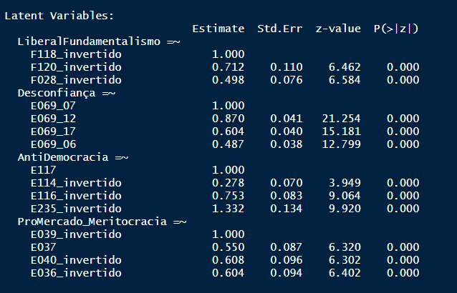



|  |  |  |  |  |
| --- | --- | --- | --- | --- |
|  | PT_ | PT_ | PT_ | PT_ |
| Predictors | Odds Ratios | Odds Ratios | Odds Ratios | Odds Ratios |
| (Intercept) | 0.17  (0.19) | 0.26 *** (0.02) | 0.79  (0.12) | 0.38  (0.45) |
| X049 | 0.99  (0.04) |  |  | 0.98  (0.04) |
| Gender | 0.89  (0.12) |  |  | 1.00  (0.15) |
| region76002 | 7.49  (9.23) |  |  | 9.33  (12.10) |
| region76003 | 4.15  (5.02) |  |  | 9.08  (11.34) |
| region76005 | 13.90 * (15.57) |  |  | 11.83 * (13.78) |
| region76006 | 11.66 * (12.17) |  |  | 19.63 ** (21.14) |
| region76007 | 6.35  (6.71) |  |  | 11.18 * (12.16) |
| region76008 | 2.43  (2.75) |  |  | 3.42  (4.01) |
| region76009 | 1.93  (2.18) |  |  | 4.37  (5.10) |
| region76010 | 1.22  (1.46) |  |  | 2.27  (2.77) |
| region76011 | 2.06  (2.47) |  |  | 3.98  (4.91) |
| region76012 | 0.89  (1.29) |  |  | 0.97  (1.45) |
| region76013 | 2.52  (2.64) |  |  | 4.20  (4.53) |
| region76014 | 5.02  (5.54) |  |  | 6.20  (7.09) |
| region76015 | 7.23  (7.93) |  |  | 19.97 ** (22.69) |
| region76016 | 3.02  (3.21) |  |  | 5.65  (6.19) |
| region76017 | 13.58 * (14.32) |  |  | 22.67 ** (24.67) |
| region76018 | 9.40 * (10.31) |  |  | 15.21 * (17.24) |
| region76019 | 3.69  (3.86) |  |  | 5.37  (5.80) |
| region76020 | 1.77  (2.25) |  |  | 3.07  (4.03) |
| region76021 | 2.79  (2.95) |  |  | 4.29  (4.66) |
| region76022 | 5.37  (7.03) |  |  | 12.50  (16.74) |
| region76024 | 2.68  (2.96) |  |  | 3.88  (4.38) |
| region76025 | 6.57  (6.79) |  |  | 10.03 * (10.67) |
| region76026 | 1.97  (2.93) |  |  | 2.71  (4.16) |
| region76027 | 0.00  (0.01) |  |  | 0.00  (0.00) |
| raca_brancTRUE | 0.73 * (0.10) |  |  | 0.68 * (0.10) |
| renda_subj_numeric | 1.05  (0.12) |  |  | 1.04  (0.12) |
| idade_faixa | 0.88  (0.09) |  |  | 0.89  (0.09) |
| escolaridade_niveis | 0.71 ** (0.07) |  |  | 0.61 *** (0.07) |
| status_emploSelf Employed | 1.17  (0.23) |  |  | 1.12  (0.24) |
| status_emploHousewife | 1.11  (0.27) |  |  | 0.97  (0.25) |
| status_emploRetired | 1.06  (0.24) |  |  | 1.22  (0.29) |
| status_emploStudent | 1.10  (0.33) |  |  | 1.07  (0.35) |
| status_emploOthers | 0.99  (0.18) |  |  | 0.97  (0.19) |
| religionDo not belong to a denomination | 0.97  (0.18) |  |  | 0.93  (0.19) |
| religionOthers | 0.86  (0.12) |  |  | 0.87  (0.13) |
| fundamentalism |  | 1.22  (0.50) | 2.07  (0.90) | 0.92  (0.47) |
| antidemocr |  | 0.12 ** (0.08) | 0.10 ** (0.08) | 0.08 ** (0.06) |
| desconfia |  | 0.38 *** (0.11) | 0.45 ** (0.13) | 0.61  (0.19) |
| promercado |  | 0.12 *** (0.06) | 0.12 *** (0.07) | 0.22 * (0.14) |
| autoloc_dir_esqCenter |  |  | 0.25 *** (0.04) | 0.24 *** (0.05) |
| autoloc_dir_esqRight |  |  | 0.32 *** (0.06) | 0.27 *** (0.05) |
| autoloc_dir_esqDon't Know |  |  | 0.20 *** (0.03) | 0.16 *** (0.03) |
| interesse |  |  | 0.96  (0.18) | 1.25  (0.26) |
| Observations | 1733 | 1762 | 1734 | 1707 |
| R2 Tjur | 0.091 | 0.019 | 0.088 | 0.180 |
| * p<0.05   ** p<0.01   *** p<0.001 | | | | |

#

Chile – partido mais citado Renovación Nacional 5,6% da amostra

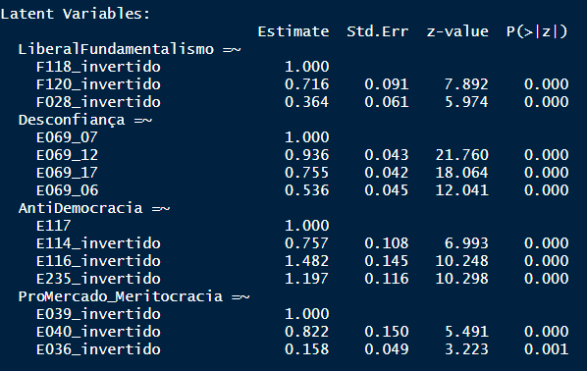



|  |  |  |  |  |
| --- | --- | --- | --- | --- |
|  | RN_ | RN_ | RN_ | RN_ |
| Predictors | Odds Ratios | Odds Ratios | Odds Ratios | Odds Ratios |
| (Intercept) | 0.00 *** (0.00) | 0.06 *** (0.01) | 0.04 *** (0.01) | 0.00 *** (0.00) |
| Gender | 0.74  (0.21) |  |  | 0.83  (0.26) |
| X049 | 1.10  (0.08) |  |  | 1.12  (0.10) |
| idade_faixa | 1.57  (0.39) |  |  | 1.13  (0.32) |
| escolaridade_niveis | 1.42  (0.37) |  |  | 1.40  (0.40) |
| status_emploSelf Employed | 1.45  (0.74) |  |  | 1.24  (0.70) |
| status_emploHousewife | 0.17  (0.18) |  |  | 0.19  (0.20) |
| status_emploRetired | 0.85  (0.40) |  |  | 0.70  (0.36) |
| status_emploStudent | 1.91  (1.37) |  |  | 1.48  (1.15) |
| status_emploOthers | 1.29  (0.61) |  |  | 0.86  (0.45) |
| rend_subjDK | 0.00  (0.00) |  |  | 0.00  (0.00) |
| rend_subjLow | 2.19  (1.83) |  |  | 4.46  (4.04) |
| rend_subjMedium | 2.21  (1.68) |  |  | 2.93  (2.33) |
| religionCatholic | 2.86 * (1.23) |  |  | 3.24 * (1.56) |
| religionOthers | 2.82 * (1.43) |  |  | 4.39 ** (2.52) |
| *fundamentalism* |  | *4.86  (4.01)* | *2.64  (2.26)* | *1.72  (1.59)* |
| *antidemocr* |  | *0.16  (0.25)* | *0.06  (0.10)* | *0.07  (0.13)* |
| *promercado* |  | *0.40  (0.33)* | *0.36  (0.33)* | *0.37  (0.34)* |
| *desconfia* |  | *1.75  (1.27)* | *1.17  (0.91)* | *0.98  (0.81)* |
| autoloc_dir_esqCenter |  |  | 0.67  (0.39) | 0.67  (0.40) |
| autoloc_dir_esqRight |  |  | 6.19 *** (2.54) | 7.25 *** (3.16) |
| autoloc_dir_esqDon't Know |  |  | 0.20 * (0.16) | 0.24  (0.19) |
| interesse |  |  | 0.82  (0.42) | 0.72  (0.40) |

#Colômbia

Partido mais citado = Liberal 13,9%

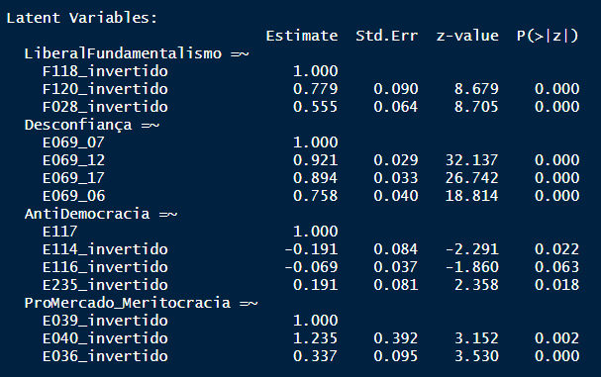

decidi abdicar de Antidemocracia

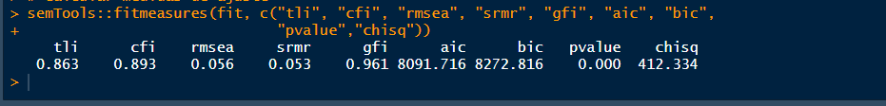

|  |  |  |  |  |
| --- | --- | --- | --- | --- |
|  | LiberalParty | LiberalParty | LiberalParty | LiberalParty |
| Predictors | Odds Ratios | Odds Ratios | Odds Ratios | Odds Ratios |
| (Intercept) | 0.47  (0.34) | 0.16 *** (0.01) | 0.13 *** (0.03) | 0.35  (0.26) |
| Gender | 1.14  (0.22) |  |  | 1.24  (0.25) |
| X049 | 0.78 *** (0.04) |  |  | 0.77 *** (0.04) |
| region170003 | 1.79  (0.67) |  |  | 1.72  (0.64) |
| region170005 | 5.99 *** (2.47) |  |  | 6.11 *** (2.57) |
| region170006 | 2.24  (1.05) |  |  | 2.01  (0.95) |
| region170007 | 0.13  (0.15) |  |  | 0.14  (0.16) |
| region170008 | 0.88  (0.62) |  |  | 0.92  (0.65) |
| region170009 | 1.60  (1.14) |  |  | 1.20  (0.87) |
| region170011 | 4.32 ** (2.27) |  |  | 3.81 * (2.03) |
| region170012 | 2.33  (1.69) |  |  | 1.94  (1.42) |
| region170013 | 2.94 * (1.39) |  |  | 2.37  (1.14) |
| region170014 | 0.98  (0.48) |  |  | 0.98  (0.49) |
| region170015 | 1.23  (0.90) |  |  | 0.91  (0.68) |
| region170018 | 0.24  (0.26) |  |  | 0.23  (0.24) |
| region170019 | 1.10  (0.76) |  |  | 1.05  (0.73) |
| region170020 | 1.43  (0.78) |  |  | 1.31  (0.73) |
| region170021 | 0.75  (0.53) |  |  | 0.65  (0.47) |
| region170022 | 4.22 ** (1.99) |  |  | 4.74 ** (2.27) |
| region170023 | 0.39  (0.31) |  |  | 0.35  (0.29) |
| region170024 | 3.21  (2.41) |  |  | 2.67  (2.04) |
| region170025 | 0.80  (0.88) |  |  | 0.95  (1.04) |
| region170026 | 0.60  (0.49) |  |  | 0.51  (0.41) |
| region170027 | 1.32  (1.12) |  |  | 1.10  (0.94) |
| region170028 | 1.24  (0.60) |  |  | 1.20  (0.60) |
| region170029 | 6.74 *** (3.31) |  |  | 6.58 *** (3.30) |
| region170030 | 2.08  (1.07) |  |  | 2.04  (1.07) |
| region170031 | 1.43  (0.59) |  |  | 1.45  (0.61) |
| idade_faixa | 1.46 ** (0.18) |  |  | 1.44 ** (0.18) |
| escolaridade_niveis | 0.65 *** (0.08) |  |  | 0.66 ** (0.08) |
| status_emploSelf Employed | 1.43  (0.39) |  |  | 1.48  (0.41) |
| status_emploHousewife | 1.38  (0.39) |  |  | 1.38  (0.39) |
| status_emploRetired | 2.55 * (1.13) |  |  | 2.35  (1.04) |
| status_emploStudent | 1.55  (0.59) |  |  | 1.58  (0.62) |
| status_emploOthers | 1.84 * (0.46) |  |  | 1.91 ** (0.48) |
| rend_subjLow | 0.43 ** (0.11) |  |  | 0.47 ** (0.13) |
| rend_subjMedium | 0.49 ** (0.12) |  |  | 0.54 * (0.14) |
| religionCatholic | 0.95  (0.18) |  |  | 0.88  (0.17) |
| religionOthers | 1.22  (0.30) |  |  | 1.13  (0.29) |
| *fundamentalism* |  | *2.28  (1.04)* | *1.74  (0.82)* | *0.80  (0.43)* |
| *promercado* |  | *1.06  (0.75)* | *1.27  (0.90)* | *4.21  (3.29)* |
| *desconfia* |  | *0.33 ** (0.13)* | *0.38 * (0.16)* | *0.55  (0.26)* |
| autoloc_dir_esqCenter |  |  | 0.69  (0.17) | 0.67  (0.18) |
| autoloc_dir_esqRight |  |  | 1.76 ** (0.37) | 1.56  (0.37) |
| interesse |  |  | 0.91  (0.21) | 1.09  (0.29) |
| Observations | 1515 | 1520 | 1520 | 1515 |
| R2 Tjur | 0.127 | 0.009 | 0.027 | 0.144 |
| * p<0.05   ** p<0.01   *** p<0.001 | | | | |

#

Equador – partido + citado= Alianza PAIS 27,3% da amostra



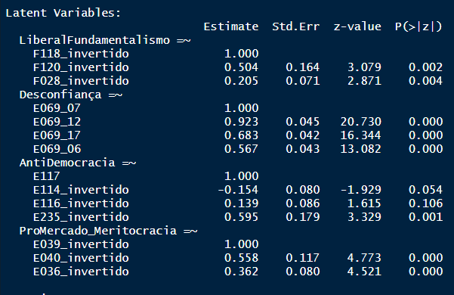

OK

|  |  |  |  |  |
| --- | --- | --- | --- | --- |
|  | Alianza_PAIS | Alianza_PAIS | Alianza_PAIS | Alianza_PAIS |
| Predictors | Odds Ratios | Odds Ratios | Odds Ratios | Odds Ratios |
| (Intercept) | 0.88  (0.41) | 0.37 *** (0.02) | 0.35 *** (0.06) | 0.70  (0.36) |
| Gender | 0.97  (0.14) |  |  | 1.01  (0.15) |
| X049 | 0.94  (0.03) |  |  | 0.95  (0.03) |
| idade_faixa | 0.79 * (0.08) |  |  | 0.85  (0.09) |
| escolaridade_niveis | 0.80 * (0.08) |  |  | 0.80 * (0.08) |
| status_emploSelf Employed | 0.97  (0.20) |  |  | 0.94  (0.20) |
| status_emploHousewife | 1.02  (0.25) |  |  | 0.99  (0.25) |
| status_emploRetired | 1.39  (0.53) |  |  | 1.50  (0.58) |
| status_emploStudent | 1.09  (0.31) |  |  | 1.14  (0.33) |
| status_emploOthers | 1.03  (0.20) |  |  | 1.02  (0.20) |
| rend_subj_numericc | 1.13  (0.13) |  |  | 1.08  (0.13) |
| religionCatholic | 1.31  (0.19) |  |  | 1.24  (0.19) |
| religionOthers | 1.10  (0.23) |  |  | 1.15  (0.25) |
| fundamentalism |  | 0.85  (0.24) | 0.87  (0.24) | 0.82  (0.24) |
| antidemocr |  | 0.26 * (0.17) | 0.28  (0.19) | 0.24 * (0.16) |
| promercado |  | 0.70  (0.29) | 0.82  (0.34) | 0.85  (0.36) |
| desconfia |  | 0.24 *** (0.08) | 0.31 *** (0.11) | 0.36 ** (0.13) |
| autoloc_dir_esqCenter |  |  | 0.78  (0.15) | 0.78  (0.16) |
| autoloc_dir_esqRight |  |  | 1.38  (0.26) | 1.39  (0.27) |
| autoloc_dir_esqDon't Know |  |  | 0.52 * (0.17) | 0.48 * (0.16) |
| interesse |  |  | 1.21  (0.25) | 1.21  (0.26) |
| Observations | 1187 | 1200 | 1199 | 1186 |
| R2 Tjur | 0.016 | 0.023 | 0.041 | 0.055 |
| * p<0.05   ** p<0.01   *** p<0.001 | | | | |

#

# Guatemala - Partido + citado: Vamos 88,6%

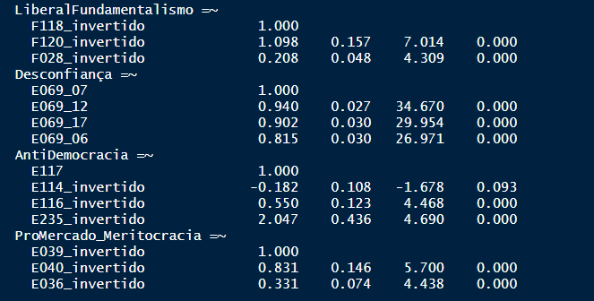



|  |  |  |  |  |
| --- | --- | --- | --- | --- |
|  | Vamos | Vamos | Vamos | Vamos |
| Predictors | Odds Ratios | Odds Ratios | Odds Ratios | Odds Ratios |
| (Intercept) | 50015496.16  (79744593689.54) | 8.20 *** (0.77) | 7.66 *** (1.94) | 64144364.05  (103017207182.38) |
| Gender | 0.62 * (0.13) |  |  | 0.59 * (0.12) |
| X049 | 0.96  (0.13) |  |  | 0.97  (0.13) |
| region320002 | 0.00  (0.00) |  |  | 0.00  (0.00) |
| region320003 | 0.00  (0.00) |  |  | 0.00  (0.00) |
| region320004 | 0.65  (1765.17) |  |  | 0.62  (1694.20) |
| region320005 | 0.00  (0.00) |  |  | 0.00  (0.00) |
| region320006 | 0.00  (0.00) |  |  | 0.00  (0.00) |
| region320007 | 0.00  (0.00) |  |  | 0.00  (0.00) |
| region320008 | 1.18  (2205.30) |  |  | 1.77  (3297.38) |
| region320009 | 0.00  (0.00) |  |  | 0.00  (0.00) |
| region320010 | 0.00  (0.00) |  |  | 0.00  (0.00) |
| region320011 | 0.00  (0.00) |  |  | 0.00  (0.00) |
| region320012 | 1.19  (2353.43) |  |  | 1.68  (3408.83) |
| region320013 | 0.00  (0.00) |  |  | 0.00  (0.00) |
| region320014 | 0.97  (1823.74) |  |  | 1.71  (3229.52) |
| region320015 | 0.97  (2289.03) |  |  | 0.91  (2177.30) |
| region320016 | 0.00  (0.00) |  |  | 0.00  (0.00) |
| region320017 | 0.00  (0.00) |  |  | 0.00  (0.00) |
| region320018 | 0.00  (0.00) |  |  | 0.00  (0.00) |
| region320019 | 0.00  (0.00) |  |  | 0.00  (0.00) |
| region320020 | 0.00  (0.00) |  |  | 0.00  (0.00) |
| region320021 | 0.00  (0.00) |  |  | 0.00  (0.00) |
| region320022 | 0.98  (1965.43) |  |  | 1.17  (2325.09) |
| idade_faixa | 0.98  (0.15) |  |  | 0.90  (0.14) |
| escolaridade_niveis | 1.42 ** (0.18) |  |  | 1.43 ** (0.19) |
| status_emploSelf Employed | 2.73 * (1.10) |  |  | 2.80 * (1.15) |
| status_emploHousewife | 2.51 * (0.98) |  |  | 2.62 * (1.04) |
| status_emploStudent | 1.55  (0.49) |  |  | 1.78  (0.58) |
| status_emploOthers | 1.03  (0.24) |  |  | 1.08  (0.26) |
| rend_subjDK | 3.38  (3.59) |  |  | 1.38  (1.50) |
| rend_subjLow | 0.91  (0.33) |  |  | 0.86  (0.32) |
| rend_subjMedium | 0.91  (0.21) |  |  | 0.80  (0.19) |
| religionCatholic | 0.78  (0.25) |  |  | 0.70  (0.23) |
| religionOthers | 0.77  (0.26) |  |  | 0.61  (0.21) |
| fundamentalism |  | 5.14 *** (2.36) | 4.76 *** (2.21) | 8.82 *** (4.71) |
| promercado |  | 0.51  (0.39) | 0.49  (0.37) | 0.36  (0.29) |
| antidemocr |  | 0.25  (0.32) | 0.21  (0.26) | 0.56  (0.78) |
| desconfia |  | 1.32  (0.66) | 1.24  (0.63) | 0.83  (0.47) |
| autoloc_dir_esqCenter |  |  | 1.39  (0.35) | 1.23  (0.33) |
| autoloc_dir_esqRight |  |  | 1.24  (0.29) | 1.22  (0.31) |
| interesse |  |  | 0.72  (0.23) | 0.63  (0.22) |
| Observations | 1183 | 1229 | 1214 | 1168 |
| R2 Tjur | 0.046 | 0.013 | 0.016 | 0.071 |

#

México

Partido Mais citado: MORENA 28%

Latent Variables:

Estimate Std.Err z-value P(>|z|)

LiberalFundamentalismo =~

F118_invertido 1.000

F120_invertido 1.222 0.285 4.292 0.000

F028_invertido 0.343 0.067 5.095 0.000

Desconfiança =~

E069_07 1.000

E069_12 0.897 0.034 26.376 0.000

E069_17 1.124 0.042 26.920 0.000

E069_06 1.050 0.041 25.665 0.000

AntiDemocracia =~

E117 1.000

E114_invertido -0.331 0.062 -5.307 0.000

E116_invertido -0.251 0.058 -4.312 0.000

E235_invertido 0.327 0.058 5.599 0.000

ProMercado_Meritocracia =~

E039_invertido 1.000

E040_invertido 1.075 0.154 6.971 0.000

E036_invertido 0.496 0.075 6.576 0.000

> # Calcular medidas de ajuste

> semTools::fitmeasures(fit, c("tli", "cfi", "rmsea", "srmr", "gfi", "aic", "bic",

+ "pvalue","chisq"))#refazer sem antidemoc

tli cfi rmsea srmr gfi aic bic pvalue chisq

0.875 0.902 0.051 0.037 0.966 8643.474 8829.189 0.000 394.692

|  |  |  |  |  |
| --- | --- | --- | --- | --- |
|  | MORENA_ | MORENA_ | MORENA_ | MORENA_ |
| Predictors | Odds Ratios | Odds Ratios | Odds Ratios | Odds Ratios |
| (Intercept) | 0.43  (0.21) | 0.39 *** (0.02) | 0.68 ** (0.08) | 0.75  (0.40) |
| Gender | 0.82  (0.11) |  |  | 0.94  (0.13) |
| X049 | 1.01  (0.03) |  |  | 1.02  (0.03) |
| region484002 | 0.37  (0.25) |  |  | 0.31  (0.21) |
| region484003 | 3.06 ** (1.12) |  |  | 3.87 *** (1.51) |
| region484005 | 0.39  (0.43) |  |  | 0.71  (0.80) |
| region484006 | 0.86  (0.35) |  |  | 1.03  (0.44) |
| region484007 | 0.58  (0.39) |  |  | 0.71  (0.49) |
| region484008 | 1.65  (0.55) |  |  | 1.63  (0.57) |
| region484009 | 0.62  (0.25) |  |  | 0.73  (0.31) |
| region484010 | 0.20 * (0.15) |  |  | 0.15 * (0.12) |
| region484011 | 0.27 ** (0.12) |  |  | 0.28 ** (0.13) |
| region484012 | 1.68  (0.64) |  |  | 1.90  (0.75) |
| region484013 | 0.85  (0.36) |  |  | 1.03  (0.46) |
| region484014 | 1.32  (0.37) |  |  | 1.46  (0.44) |
| region484015 | 0.85  (0.21) |  |  | 0.82  (0.21) |
| region484016 | 1.17  (0.40) |  |  | 1.25  (0.45) |
| region484017 | 1.12  (0.53) |  |  | 1.15  (0.59) |
| region484018 | 1.81  (0.91) |  |  | 1.71  (0.92) |
| region484019 | 0.31 ** (0.13) |  |  | 0.33 ** (0.14) |
| region484020 | 1.29  (0.45) |  |  | 1.53  (0.56) |
| region484021 | 1.14  (0.35) |  |  | 1.17  (0.38) |
| region484022 | 0.41  (0.23) |  |  | 0.40  (0.24) |
| region484023 | 0.93  (0.50) |  |  | 0.77  (0.45) |
| region484024 | 0.78  (0.32) |  |  | 0.77  (0.34) |
| region484025 | 1.12  (0.45) |  |  | 1.26  (0.53) |
| region484026 | 2.71 ** (1.00) |  |  | 3.24 ** (1.26) |
| region484027 | 5.41 *** (2.44) |  |  | 9.30 *** (4.42) |
| region484028 | 0.45  (0.20) |  |  | 0.44  (0.21) |
| region484029 | 1.68  (0.84) |  |  | 1.67  (0.91) |
| region484030 | 1.30  (0.38) |  |  | 1.53  (0.47) |
| region484031 | 0.96  (0.47) |  |  | 1.46  (0.75) |
| region484032 | 0.72  (0.43) |  |  | 0.93  (0.57) |
| idade_faixa | 0.87  (0.07) |  |  | 0.85  (0.07) |
| escolaridade_niveis | 1.46 *** (0.14) |  |  | 1.34 ** (0.14) |
| status_emploSelf Employed | 0.91  (0.16) |  |  | 0.87  (0.17) |
| status_emploHousewife | 0.97  (0.18) |  |  | 0.92  (0.17) |
| status_emploStudent | 0.60  (0.20) |  |  | 0.54  (0.19) |
| status_emploOthers | 0.67 * (0.10) |  |  | 0.65 ** (0.11) |
| rend_subjDK | 0.16 * (0.13) |  |  | 0.23  (0.19) |
| rend_subjLow | 0.76  (0.15) |  |  | 0.69  (0.15) |
| rend_subjMedium | 0.85  (0.16) |  |  | 0.81  (0.16) |
| religionCatholic | 1.07  (0.19) |  |  | 1.11  (0.21) |
| religionOthers | 1.04  (0.24) |  |  | 1.10  (0.27) |
| fundamentalism |  | 0.54  (0.22) | 0.77  (0.33) | 1.16  (0.54) |
| promercado |  | 2.40  (1.20) | 1.94  (1.02) | 2.88  (1.67) |
| antidemocr |  | 1.34  (0.47) | 1.86  (0.69) | 2.28 * (0.92) |
| desconfia |  | 1.18  (0.36) | 1.56  (0.52) | 1.50  (0.54) |
| autoloc_dir_esqCenter |  |  | 0.33 *** (0.05) | 0.29 *** (0.05) |
| autoloc_dir_esqRight |  |  | 0.27 *** (0.04) | 0.23 *** (0.03) |
| autoloc_dir_esqDon't Know |  |  | 0.20 *** (0.05) | 0.18 *** (0.05) |
| interesse |  |  | 2.64 *** (0.49) | 2.87 *** (0.59) |
| Observations | 1714 | 1741 | 1740 | 1713 |
| R2 Tjur | 0.089 | 0.003 | 0.092 | 0.182 |
| * p<0.05   ** p<0.01   *** p<0.001 | | | | |

#

Nicarágua

FSLN = 29,7% + citado

Latent Variables:

Estimate Std.Err z-value P(>|z|)

LiberalFundamentalismo =~

F118_invertido 1.000

F120_invertido 0.590 0.179 3.289 0.001

F028_invertido 0.373 0.110 3.389 0.001

Desconfiança =~

E069_07 1.000

E069_12 0.824 0.026 31.424 0.000

E069_17 0.935 0.030 31.470 0.000

E069_06 0.951 0.031 30.262 0.000

AntiDemocracia =~

E117 1.000

E114_invertido -2.719 0.603 -4.512 0.000

E116_invertido -1.664 0.354 -4.694 0.000

E235_invertido 0.365 0.183 1.995 0.046

ProMercado_Meritocracia =~

E039_invertido 1.000

E040_invertido 0.614 0.214 2.869 0.004

E036_invertido 3.146 1.537 2.047 0.041

Antidemocracia abandonada (contraintuitivo)

> semTools::fitmeasures(fit, c("tli", "cfi", "rmsea", "srmr", "gfi", "aic", "bic",

+ "pvalue","chisq"))#refazer sem antidemoc

tli cfi rmsea srmr gfi aic bic pvalue chisq

0.885 0.910 0.057 0.041 0.959 7680.422 7853.484 0.000 350.461

|  |  |  |  |  |
| --- | --- | --- | --- | --- |
|  | FSLN_ | FSLN_ | FSLN_ | FSLN_ |
| Predictors | Odds Ratios | Odds Ratios | Odds Ratios | Odds Ratios |
| (Intercept) | 0.68  (0.38) | 0.35 *** (0.03) | 0.52 *** (0.09) | 0.28  (0.20) |
| Gender | 1.08  (0.17) |  |  | 1.22  (0.24) |
| X049 | 0.93  (0.04) |  |  | 0.96  (0.06) |
| region558002 | 1.15  (0.59) |  |  | 1.55  (1.04) |
| region558003 | 1.18  (0.54) |  |  | 1.95  (1.14) |
| region558004 | 0.53  (0.29) |  |  | 0.92  (0.65) |
| region558005 | 0.61  (0.32) |  |  | 1.26  (0.83) |
| region558006 | 0.66  (0.36) |  |  | 0.86  (0.59) |
| region558007 | 0.18 ** (0.10) |  |  | 0.61  (0.42) |
| region558008 | 0.81  (0.38) |  |  | 0.87  (0.54) |
| region558009 | 1.45  (0.75) |  |  | 3.13  (2.08) |
| region558010 | 0.82  (0.35) |  |  | 1.13  (0.62) |
| region558011 | 0.51  (0.25) |  |  | 0.63  (0.40) |
| region558012 | 1.31  (0.58) |  |  | 1.75  (0.99) |
| region558013 | 0.67  (0.35) |  |  | 0.48  (0.32) |
| region558014 | 1.61  (0.88) |  |  | 1.36  (1.01) |
| region558015 | 0.42  (0.24) |  |  | 0.96  (0.67) |
| region558016 | 0.85  (0.55) |  |  | 1.35  (1.10) |
| region558017 | 1.37  (0.71) |  |  | 1.75  (1.15) |
| idade_faixa | 1.16  (0.11) |  |  | 1.22  (0.15) |
| escolaridade_niveis | 1.15  (0.10) |  |  | 1.07  (0.12) |
| status_emploSelf Employed | 0.59 * (0.15) |  |  | 0.61  (0.19) |
| status_emploHousewife | 0.76  (0.17) |  |  | 0.70  (0.20) |
| status_emploStudent | 0.49 ** (0.13) |  |  | 0.52 * (0.17) |
| status_emploOthers | 0.87  (0.16) |  |  | 0.77  (0.18) |
| rend_subjLow | 0.58 * (0.13) |  |  | 0.91  (0.25) |
| rend_subjMedium | 0.74  (0.15) |  |  | 1.34  (0.35) |
| religionCatholic | 1.01  (0.19) |  |  | 0.97  (0.23) |
| religionOthers | 1.13  (0.21) |  |  | 1.14  (0.27) |
| fundamentalism |  | 0.82  (0.41) | 1.72  (0.94) | 1.74  (1.01) |
| promercado |  | 0.04 ** (0.05) | 0.05 * (0.06) | 0.08  (0.11) |
| desconfia |  | 0.01 *** (0.00) | 0.04 *** (0.01) | 0.03 *** (0.01) |
| autoloc_dir_esqCenter |  |  | 0.26 *** (0.06) | 0.25 *** (0.06) |
| autoloc_dir_esqRight |  |  | 0.44 *** (0.09) | 0.44 *** (0.09) |
| autoloc_dir_esqDon't Know |  |  | 0.14 *** (0.03) | 0.14 *** (0.04) |
| interesse |  |  | 5.86 *** (1.43) | 6.15 *** (1.60) |
| Observations | 1199 | 1200 | 1200 | 1199 |
| R2 Tjur | 0.072 | 0.237 | 0.351 | 0.385 |
| * p<0.05   ** p<0.01   *** p<0.001 | | | | |

#

Peru onda 7

*Acción Popular* 8,2%

Latent Variables:

Estimate Std.Err z-value P(>|z|)

LiberalFundamentalismo =~

F118_invertido 1.000

F120_invertido 1.353 0.252 5.368 0.000

F028_invertido 0.334 0.059 5.661 0.000

Desconfiança =~

E069_07 1.000

E069_12 1.040 0.040 25.745 0.000

E069_17 1.090 0.047 23.326 0.000

E069_06 0.943 0.055 17.208 0.000

AntiDemocracia =~

E117 1.000

E114_invertido 0.253 0.141 1.801 0.072

E116_invertido 0.711 0.192 3.705 0.000

E235_invertido 1.010 0.223 4.526 0.000

ProMercado_Meritocracia =~

E039_invertido 1.000

E040_invertido 0.722 0.107 6.756 0.000

E036_invertido 0.128 0.043 2.998 0.003

> # Calcular medidas de ajuste

> semTools::fitmeasures(fit, c("tli", "cfi", "rmsea", "srmr", "gfi", "aic", "bic",

+ "pvalue","chisq"))#refazer sem antidemoc

tli cfi rmsea srmr gfi aic bic pvalue chisq

0.839 0.874 0.062 0.046 0.956 -440.825 -262.521 0.000 450.280

|  |  |  |  |  |
| --- | --- | --- | --- | --- |
|  | AccionPopular | AccionPopular | AccionPopular | AccionPopular |
| Predictors | Odds Ratios | Odds Ratios | Odds Ratios | Odds Ratios |
| (Intercept) | 0.34  (0.21) | 0.09 *** (0.01) | 0.05 *** (0.02) | 0.35  (0.29) |
| Gender | 1.02  (0.22) |  |  | 1.02  (0.23) |
| raca_brancTRUE | 0.69  (0.37) |  |  | 0.76  (0.42) |
| idade_faixa | 0.89  (0.13) |  |  | 0.91  (0.13) |
| status_emploSelf Employed | 0.83  (0.23) |  |  | 0.72  (0.21) |
| status_emploHousewife | 0.65  (0.24) |  |  | 0.59  (0.23) |
| status_emploStudent | 1.31  (0.47) |  |  | 1.31  (0.48) |
| status_emploOthers | 1.40  (0.40) |  |  | 1.28  (0.37) |
| rend_subjDK | 0.00  (0.00) |  |  | 0.00  (0.00) |
| rend_subjLow | 0.52  (0.19) |  |  | 0.48  (0.18) |
| rend_subjMedium | 0.58  (0.18) |  |  | 0.57  (0.18) |
| religionCatholic | 0.59  (0.28) |  |  | 0.54  (0.26) |
| religionOthers | 0.43  (0.22) |  |  | 0.39  (0.20) |
| fundamentalism |  | 0.70  (0.46) | 0.96  (0.65) | 1.00  (0.68) |
| antidemocr |  | 10.68  (27.10) | 16.45  (42.94) | 13.52  (35.76) |
| desconfia |  | 0.19 ** (0.12) | 0.23 * (0.15) | 0.24 * (0.16) |
| promercado |  | 3.59  (2.46) | 3.77  (2.63) | 3.45  (2.46) |
| autoloc_dir_esqCenter |  |  | 1.13  (0.41) | 1.15  (0.42) |
| autoloc_dir_esqRight |  |  | 1.47  (0.49) | 1.50  (0.51) |
| autoloc_dir_esqDon't Know |  |  | 1.30  (0.52) | 1.42  (0.58) |
| interesse |  |  | 1.80  (0.59) | 1.65  (0.56) |
| escolaridade_niveis |  |  | 1.05  (0.15) | 0.83  (0.14) |
| Observations | 1387 | 1400 | 1397 | 1384 |
| R2 Tjur | 0.013 | 0.007 | 0.012 | 0.025 |
| * p<0.05   ** p<0.01   *** p<0.001 | | | | |

#

Uruguai

Partido + citado: Frente Amplio (40,9%)

Latent Variables:

Estimate Std.Err z-value P(>|z|)

LiberalFundamentalismo =~

F118_invertido 1.000

F120_invertido 1.606 0.203 7.919 0.000

F028_invertido 0.481 0.072 6.673 0.000

Desconfiança =~

E069_07 1.000

E069_12 0.740 0.040 18.543 0.000

E069_17 0.607 0.039 15.492 0.000

E069_06 0.405 0.037 10.955 0.000

AntiDemocracia =~

E117 1.000

E114_invertido 1.170 0.136 8.596 0.000

E116_invertido 1.302 0.140 9.283 0.000

E235_invertido 0.578 0.078 7.447 0.000

ProMercado_Meritocracia =~

E039_invertido 1.000

E040_invertido 0.746 0.190 3.931 0.000

E036_invertido 0.538 0.139 3.863 0.000

> semTools::fitmeasures(fit, c("tli", "cfi", "rmsea", "srmr", "gfi", "aic", "bic",

+ "pvalue","chisq"))#refazer sem antidemoc

tli cfi rmsea srmr gfi aic bic pvalue chisq

0.711 0.775 0.082 0.070 0.925 5197.275 5364.138 0.000 547.139

|  |  |  |  |  |
| --- | --- | --- | --- | --- |
|  | FrenteAmplio_ | FrenteAmplio_ | FrenteAmplio_ | FrenteAmplio_ |
| Predictors | Odds Ratios | Odds Ratios | Odds Ratios | Odds Ratios |
| (Intercept) | 0.53  (0.35) | 0.67 *** (0.05) | 7.74 *** (2.40) | 9.47 * (9.58) |
| Gender | 1.05  (0.16) |  |  | 0.94  (0.21) |
| region858002 | 3.53 * (1.96) |  |  | 4.28  (3.59) |
| region858003 | 0.68  (0.54) |  |  | 2.52  (2.73) |
| region858004 | 1.40  (0.95) |  |  | 6.57  (6.42) |
| region858005 | 1.22  (1.09) |  |  | 3.03  (3.95) |
| region858006 | 0.30  (0.35) |  |  | 0.51  (0.77) |
| region858007 | 0.93  (0.66) |  |  | 2.83  (2.90) |
| region858008 | 2.85  (2.44) |  |  | 4.74  (5.72) |
| region858009 | 1.73  (1.04) |  |  | 3.30  (2.98) |
| region858011 | 1.57  (1.00) |  |  | 2.33  (2.24) |
| region858012 | 3.54  (3.00) |  |  | 9.27  (10.89) |
| region858013 | 1.45  (1.00) |  |  | 3.51  (3.56) |
| region858014 | 1.47  (1.10) |  |  | 3.13  (3.55) |
| region858016 | 0.76  (0.50) |  |  | 0.79  (0.75) |
| region858017 | 2.71  (1.78) |  |  | 3.33  (3.32) |
| region858018 | 1.52  (1.10) |  |  | 8.36 * (8.53) |
| region858019 | 1.56  (1.00) |  |  | 2.73  (2.61) |
| region858020 | 0.57  (0.55) |  |  | 3.78  (4.44) |
| raca_brancTRUE | 1.03  (0.17) |  |  | 0.97  (0.22) |
| X049 | 1.13 * (0.06) |  |  | 1.09  (0.08) |
| idade_faixa | 0.73 ** (0.07) |  |  | 0.60 *** (0.09) |
| status_emploSelf Employed | 0.79  (0.23) |  |  | 0.84  (0.35) |
| status_emploHousewife | 1.28  (0.31) |  |  | 2.46 ** (0.78) |
| status_emploOthers | 1.15  (0.19) |  |  | 1.17  (0.27) |
| rend_subjDK | 0.38  (0.20) |  |  | 0.13 ** (0.10) |
| rend_subjLow | 0.64  (0.16) |  |  | 0.47 * (0.16) |
| rend_subjMedium | 0.80  (0.18) |  |  | 0.67  (0.20) |
| religionCatholic | 0.37 *** (0.09) |  |  | 0.80  (0.25) |
| religionOthers | 0.57 * (0.13) |  |  | 1.05  (0.34) |
| fundamentalism |  | 0.05 *** (0.03) | 0.07 ** (0.07) | 0.24  (0.24) |
| antidemocr |  | 0.15  (0.18) | 49.01 * (78.84) | 4.01  (7.01) |
| desconfia |  | 1.52  (0.40) | 1.09  (0.39) | 1.04  (0.40) |
| promercado |  | 0.06 *** (0.04) | 0.08 ** (0.07) | 0.08 ** (0.07) |
| autoloc_dir_esqCenter |  |  | 0.07 *** (0.02) | 0.05 *** (0.01) |
| autoloc_dir_esqRight |  |  | 0.02 *** (0.01) | 0.02 *** (0.00) |
| autoloc_dir_esqDon't Know |  |  | 0.02 *** (0.01) | 0.02 *** (0.01) |
| interesse |  |  | 1.99 * (0.55) | 2.01 * (0.59) |
| escolaridade_niveis |  |  | 0.75 * (0.10) | 0.71 * (0.10) |
| Observations | 1000 | 1000 | 994 | 994 |
| R2 Tjur | 0.094 | 0.092 | 0.473 | 0.514 |
| * p<0.05   ** p<0.01   *** p<0.001 | | | | |

#

Venezuela: PSUV (26,9%)

Latent Variables:

Estimate Std.Err z-value P(>|z|)

LiberalFundamentalismo =~

F118_invertido 1.000

F120_invertido 0.791 0.131 6.033 0.000

F028_invertido 0.411 0.075 5.496 0.000

Desconfiança =~

E069_07 1.000

E069_12 0.872 0.033 26.663 0.000

E069_17 0.794 0.034 23.112 0.000

E069_06 0.750 0.034 22.136 0.000

AntiDemocracia =~

E117 1.000

E114_invertido -0.049 0.124 -0.394 0.693

E116_invertido 1.146 0.162 7.094 0.000

E235_invertido 0.822 0.115 7.171 0.000

ProMercado_Meritocracia =~

E039_invertido 1.000

E040_invertido 0.488 0.074 6.576 0.000

E036_invertido 0.846 0.107 7.882 0.000

removi E114

Latent Variables:

Estimate Std.Err z-value P(>|z|)

LiberalFundamentalismo =~

F118_invertido 1.000

F120_invertido 0.784 0.130 6.006 0.000

F028_invertido 0.409 0.075 5.477 0.000

Desconfiança =~

E069_07 1.000

E069_12 0.872 0.033 26.662 0.000

E069_17 0.794 0.034 23.113 0.000

E069_06 0.750 0.034 22.136 0.000

AntiDemocracia =~

E117 1.000

E116_invertido 1.157 0.163 7.098 0.000

E235_invertido 0.827 0.115 7.168 0.000

ProMercado_Meritocracia =~

E039_invertido 1.000

E040_invertido 0.490 0.074 6.592 0.000

E036_invertido 0.847 0.107 7.893 0.000

ficou melhor

> semTools::fitmeasures(fit, c("tli", "cfi", "rmsea", "srmr", "gfi", "aic", "bic",

+ "pvalue","chisq"))#refazer sem antidemoc

tli cfi rmsea srmr gfi aic bic pvalue chisq

0.869 0.901 0.061 0.048 0.959 2761.378 2923.993 0.000 324.059

|  |  |  |  |  |
| --- | --- | --- | --- | --- |
|  | PSUV | PSUV | PSUV | PSUV |
| Predictors | Odds Ratios | Odds Ratios | Odds Ratios | Odds Ratios |
| (Intercept) | 0.28  (0.18) | 0.30 *** (0.02) | 1.20  (0.34) | 1.83  (1.68) |
| Gender | 0.75  (0.11) |  |  | 0.81  (0.17) |
| region862004 | 0.71  (0.27) |  |  | 0.73  (0.34) |
| region862005 | 0.81  (0.60) |  |  | 0.72  (0.75) |
| region862006 | 0.83  (0.29) |  |  | 0.75  (0.33) |
| region862007 | 0.45  (0.31) |  |  | 0.44  (0.44) |
| region862008 | 0.88  (0.31) |  |  | 0.81  (0.37) |
| region862009 | 1.64  (0.50) |  |  | 0.77  (0.35) |
| region862010 | 1.25  (0.89) |  |  | 0.71  (1.00) |
| region862012 | 0.16 ** (0.11) |  |  | 0.08 ** (0.06) |
| region862013 | 0.65  (0.32) |  |  | 0.74  (0.44) |
| region862014 | 0.62  (0.23) |  |  | 0.35 * (0.17) |
| region862015 | 0.53  (0.26) |  |  | 0.68  (0.54) |
| region862016 | 0.76  (0.23) |  |  | 0.65  (0.26) |
| region862017 | 1.47  (0.59) |  |  | 1.67  (0.90) |
| region862018 | 0.85  (0.49) |  |  | 1.02  (0.71) |
| region862019 | 0.75  (0.38) |  |  | 0.47  (0.31) |
| region862020 | 0.88  (0.39) |  |  | 0.41  (0.23) |
| region862021 | 0.19 ** (0.11) |  |  | 0.12 ** (0.09) |
| region862022 | 0.47  (0.24) |  |  | 0.20 ** (0.12) |
| region862023 | 0.63  (0.37) |  |  | 0.26  (0.21) |
| region862024 | 0.60  (0.37) |  |  | 0.13 * (0.14) |
| region862025 | 0.66  (0.20) |  |  | 0.57  (0.23) |
| raca_brancTRUE | 0.80  (0.12) |  |  | 0.84  (0.17) |
| X049 | 0.93  (0.05) |  |  | 0.87 * (0.06) |
| idade_faixa | 1.61 *** (0.15) |  |  | 1.42 ** (0.18) |
| status_emploSelf Employed | 0.78  (0.16) |  |  | 1.19  (0.33) |
| status_emploHousewife | 1.21  (0.32) |  |  | 1.38  (0.50) |
| status_emploOthers | 0.97  (0.19) |  |  | 1.43  (0.39) |
| rend_subjLow | 1.94  (0.70) |  |  | 1.56  (0.74) |
| rend_subjMedium | 1.47  (0.51) |  |  | 1.43  (0.64) |
| religionCatholic | 1.22  (0.24) |  |  | 1.06  (0.28) |
| religionOthers | 1.58  (0.38) |  |  | 1.55  (0.50) |
| fundamentalism |  | 5.17 ** (2.96) | 6.09 ** (4.07) | 4.51 * (3.39) |
| antidemocr |  | 0.06 * (0.08) | 0.26  (0.40) | 0.54  (0.93) |
| desconfia |  | 0.00 *** (0.00) | 0.02 *** (0.01) | 0.02 *** (0.01) |
| promercado |  | 0.15 ** (0.11) | 0.21  (0.18) | 0.24  (0.22) |
| autoloc_dir_esqCenter |  |  | 0.27 *** (0.06) | 0.22 *** (0.06) |
| autoloc_dir_esqRight |  |  | 0.07 *** (0.02) | 0.06 *** (0.01) |
| interesse |  |  | 7.62 *** (2.24) | 8.34 *** (2.70) |
| escolaridade_niveis |  |  | 0.80  (0.09) | 0.85  (0.11) |
| Observations | 1190 | 1190 | 1189 | 1189 |
| R2 Tjur | 0.078 | 0.229 | 0.430 | 0.467 |
| * p<0.05   ** p<0.01   *** p<0.001 | | | | |

#

final

Tabela – onda 7 – resultados da análise fatorial confirmatória

ver tabelas resultados analise fatorial confirmatoria.xlsx